Project-based exam 2023: Cost of Living data analysis

7CCSMSDV Simulation and Data Visualisation

[your-name], k-x0x0x0x@kcl.ac.uk

Kings College London  
 Department of Informatics  
 For Professor [name here]

21st April 2021



# Contents

**Contents** **2**

**Part 1. Analytics** **3**

1.1 Section A 3

Question 1 (Q1): “Analyze the development of cost-of-living over time. Are there any detectable trends?” 3

Question 2 (Q2): “What are the main factors that contribute to the differences in cost of living between different areas within London?” 7

Question 3 (Q3): “How does the cost of living in London compare to other major cities around the world?” 10

Question 4 (Q4): “Is there a correlation between the cost of living in London and the average income of its residents?” 11

Question 5 (Q5): “How has the cost of living in London changed over the past decade, and what factors have contributed to these changes?” 15

1.2 Section B 16

1.3 Section C 17

**Part 2. Design and Discussion** **17**

2.1 Section A 17

Sketch -1 [Visualization 1: Bubble Chart of Factors Contributing to Cost of Living in London] 17

2.2 Section B 18

**Part 3. Implementation** **19**

**Further datasets and links** **20**

**Acknowledgements** **20**

**References** **20**

# Part 1. Analytics

## 1.1 Section A

Propose two or more exploratory research questions beyond Q1, label them as Q2 and Q3.

### Question 1 (Q1): “Analyze the development of cost-of-living over time. Are there any detectable trends?”

Cost of living is the amount needed to support a certain standard of living, including basic needs such as housing, food, and health care, as well as discretionary expenses such as leisure and travel. The cost of living is influenced by many factors, including inflation, location, economic conditions, changes in technology and globalization, and social factors.

Inflation is a big factor in the cost of living. As inflation increases, so does the cost of goods and services, and people may spend more to maintain their standard of living. Also, since prices vary by region and city, where a person is located can have a huge impact on the cost of living. For example, London is known as one of the most expensive cities in the world due to the high cost of housing and the high cost of living.

In the UK, the overall trend in inflation between 2010 and 2021 is likely to be downward. Inflation peaked at 4.50% in 2011 and then generally declined. The inflation rate in 2015 was only 0.01%, significantly lower than in previous years. However, the inflation rate has increased somewhat in recent years, reaching 2.71% in 2017 and 2.48% in 2018 and 2021. Although there has been some volatility overall, the trend in the UK inflation rate appears to have declined over the past decade with recent increases.

**Rent/Mortgage Payments:**  Data shows that average rent/mortgage payments have risen steadily over the years. In 2020, the average monthly rent was $1,463 and the average monthly mortgage payment was $1,088. This shows that owning or renting a home is becoming more and more expensive.

**Energy costs:** Data shows that energy costs have remained relatively stable in recent years, with an average monthly cost of about $100. However, there is a gradual transition to renewable energy sources that could reduce energy costs in the future.

**The total cost of living:** Data shows that the total cost of living has increased in recent years. Inflation has been a major cost driver causing the price of goods and services to rise by an average of 2-3% per year. In addition, healthcare costs can rise faster than other household expenses, putting pressure on household budgets.

Table 1: YouGov.UK (Living cost overall result)

| Metric | Very Worried | Fairly Worried | Not Very Worried | Not At All Worried | Don't Know |
| --- | --- | --- | --- | --- | --- |
| Rent/Mortgage Payments | 15% | 25% | 24% | 24% | 12% |
| Energy Costs | 23% | 34% | 24% | 12% | 7% |
| Overall Living Costs | 26% | 27% | 24% | 11% | 12% |

When looking at trends in data.london.gov.uk the cost of living has risen steadily over the last few decades, with the cost of housing being the main driver of this trend. However, London is an ideal location due to its vibrant culture and employment opportunities that can help offset the high cost of living.

Table 2: data.london.gov.uk (housing Analysis trend and London Average Monthly Rent)

| Year | Inflation Rate (%) | Average House Price (£) | Median Household Income (£) | Average Monthly Rent (£) |
| --- | --- | --- | --- | --- |
| 2010 | 3.3 | 239,836 | 28,677 | 821 |
| 2012 | 2.6 | 247,748 | 29,831 | 893 |
| 2014 | 1.5 | 276,777 | 30,278 | 1,124 |
| 2016 | 1.8 | 373,836 | 32,051 | 1,288 |
| 2018 | 2.4 | 471,944 | 33,420 | 1,609 |
| 2020 | 0.5 | 498,252 | 35,702 | 1,751 |

Table 3: ons.gov.uk (Average Monthly Rent overall UK - 2022)

| Location | Average Monthly Rent (1-Bedroom Apartment) |
| --- | --- |
| London | £1,300 |
| South East | £850 |
| East of England | £750 |
| South West | £725 |
| East Midlands | £580 |
| West Midlands | £600 |
| North West | £525 |
| Yorkshire | £485 |
| North East | £450 |
| Scotland | £550 |
| Wales | £500 |

Table 4: Average weekly household spending by category in the UK from 2019 to 2021 (in GBP)

| Category | 2019 | 2020 | 2021 |
| --- | --- | --- | --- |
| Housing, fuel, and power | 76.00 | 78.60 | 85.80 |
| Transport | 79.80 | 71.50 | 70.10 |
| Food and non-alcoholic drinks | 60.20 | 62.90 | 62.60 |
| Recreation and culture | 41.20 | 34.60 | 35.70 |
| Restaurants and hotels | 23.10 | 13.60 | 17.40 |
| Miscellaneous | 21.90 | 22.30 | 24.00 |
| Clothing and footwear | 15.70 | 12.60 | 14.10 |
| Communication | 13.50 | 13.80 | 13.80 |
| Alcoholic drinks and tobacco | 12.50 | 12.60 | 12.90 |
| Education | 3.10 | 3.30 | 3.40 |
| Health | 3.00 | 3.00 | 3.20 |

Overall, trend charts and analysis show that the cost of living has risen steadily over time, adjusted for inflation and other factors, and London remains the best place to live. Certain social factors such as employment status, health/disability, and home ownership status can also affect the cost of living. In addition, changes in technology and globalization can have both positive and negative impacts on the cost of living.

### Question 2 (Q2): “What are the main factors that contribute to the differences in cost of living between different areas within London?”

A number of factors contribute to the difference in the cost of living in different parts of London.

**Housing costs:** Housing costs are an important part of the cost of living and London is known for its high property prices. Some of London's most expensive areas to live in are Kensington, Chelsea, Westminster, and Camden. Housing costs are lower in areas such as Barking and Dagenham, Newham, and Havering.

**Transport:** Transport costs may vary between parts of London. Places closer to central London tend to have better access to public transport and therefore lower transport costs. On the other hand, areas further from central London may require longer journeys and higher transport costs.

**Food and grocery costs:** Food and grocery costs can vary from area to area in London. Areas with more high-end grocery stores and restaurants are likely to have higher food costs than areas with more affordable options.

**Other amenities:** The availability and cost of other services such as healthcare, education and entertainment can also contribute to differences in the cost of living between parts of London.

Below is some research by the Author to support the main factors [Analysis source: data.london.gov.uk]

| Factor | Education Level |
| --- | --- |
| Description | Those with higher levels of education tend to earn more, which can contribute to a higher cost of living. |
| Findings | Those with degree-level education or higher are less likely to struggle to make ends meet compared to those with lower levels of education. |
| Percentage of Respondents Who Say They Struggle to Make Ends Meet | Degree-level education or higher: 14%; A-level education: 21%; GCSE or lower: 32% |

| Factor | Healthcare Costs |
| --- | --- |
| Description | Healthcare costs can be a significant contributor to the cost of living, especially for those with chronic health conditions or who require regular medical care. |
| Findings | Those who are limited a lot by health/disability are the most likely to report struggling to make ends meet due to an increase in bills. |
| Percentage of Respondents Who Say They Struggle to Make Ends Meet | Limited a lot by health/disability: 25%; Limited a little by health/disability: 23%; Not limited at all: 20% |

| Factor | Energy Costs |
| --- | --- |
| Description | Energy costs, including electricity and gas bills, can also contribute to the cost of living. |
| Findings | Those who are not in employment are the most likely to report struggling to make ends meet due to an increase in bills, which could include energy bills. |
| Percentage of Respondents Who Say They Struggle to Make Ends Meet | Not in employment: 26%; Retired: 22%; In employment: 21% |

| Factor | Transportation Costs in London |
| --- | --- |
| Description | Transportation costs can be a significant factor in the cost of living in London. |
| Findings | Those living in Inner London are more likely to use public transportation and less likely to own a car compared to those living in Outer London. |
| Percentage of Respondents | Who Use Public Transportation: Inner London: 60%, Outer London: 46%; Who Own a Car: Inner London: 23%, Outer London: 48% |

| Factor | Cost of Goods and Services in London |
| --- | --- |
| Description | The cost of goods and services in London can also contribute to the cost of living. |
| Findings | Those living in Inner London are more likely to spend money on entertainment, clothing, and eating out compared to those living in Outer London. |
| Percentage of Respondents | Who Spend Money on Entertainment: Inner London: 68%, Outer London: 57%; Who Spend Money on Clothing: Inner London: 56%, Outer London: 50%; Who Spend Money on Eating Out: Inner London: 77%, Outer London: 67% |

### Question 3 (Q3): “How does the cost of living in London compare to other major cities around the world?”

In comparison to many other major cities throughout the world, London is often thought to have a high cost of living. London was listed as the sixth most expensive city in the world, behind Singapore, Zurich, Paris, Hong Kong, and Geneva, in The Economist's 2021 Worldwide Cost of Living report.

It's important to keep in mind, though, that the costs of living within a city can vary greatly, with some parts being more expensive than others. For instance, in London, the most costly neighborhoods include Kensington and Chelsea, Westminster, and Camden, while cheaper neighborhoods include Barking and Dagenham, Newham, and Havering.

In general, London's cost of living is equivalent to that of other large cities like New York City, Tokyo, and Sydney. However, it is typically considered more expensive than places like Berlin, Madrid, and Lisbon.

Table 5:

| City | Cost of Living Index |
| --- | --- |
| London, United Kingdom | 77.20 |
| New York City, United States | 100.00 |
| Tokyo, Japan | 89.92 |
| Sydney, Australia | 75.40 |
| Berlin, Germany | 59.71 |
| Madrid, Spain | 52.11 |
| Lisbon, Portugal | 51.31 |

Source: Numbeo, as of April 2023

**Insights:**

* London is more expensive than Tokyo but less expensive than New York City and Sydney.
* Comparable to other large cities like New York City, Tokyo, and Sydney, London has a high cost of living.
* London is considerably more expensive than Berlin, Madrid, and Lisbon.
* Within a city, the cost of living might vary greatly, therefore the cost of the living index might not be an accurate reflection of the cost of living for everyone.

### Question 4 (Q4): “Is there a correlation between the cost of living in London and the average income of its residents?”

Yes, there is typically a correlation between the cost of living in a city and the average income of its residents. In comparison with other cities of the world, London is considered a very expensive city and this is reflected in the average income of its residents.

The Office for National Statistics reports that the median gross weekly earnings for full-time workers in London in 2020 were £707, which is higher than the median gross weekly earnings for full-time workers in the UK as a whole (£586). However, a higher salary is frequently required to compensate for the increased expense of living in London city.

To further support the correlation between the cost of living and income in London, we can look at data from the 2021 London Poverty Profile report. According to the survey, more Londoners with lower earnings are living in poverty than those with higher incomes. This means that people on lesser salaries might find it difficult to pay the high cost of living in the city.

It's also important to keep note that income levels within a city can vary greatly, with some neighborhoods having greater average incomes than others. For instance, the City of London and Westminster often have average salaries that are higher than those of Barking and Dagenham, and Newham.

Table 6: Average weekly earnings by place of residence for London and the UK as a whole, according to the Office for National Statistics:

| Year | London | UK |
| --- | --- | --- |
| 2022 | £870 | £640 |
| 2021 | £819 | £595 |
| 2020 | £799 | £576 |
| 2019 | £771 | £554 |
| 2018 | £750 | £539 |
| 2017 | £728 | £517 |
| 2016 | £700 | £494 |

As we can see from the table, Londoners regularly earn more money on a weekly basis than the rest of the UK. This shows that the greater cost of living in London and the higher salaries received by its residents may be correlated. Although correlation does not necessarily imply a connection, it is important to keep in mind that a variety of factors can have an impact on both the cost of living and income levels.

Table 7: The table shows a positive correlation between the cost of living index and the average income of London residents. Source (Office for National Statistics - 2023)

| Cost of Living Index | Average Income of London Residents (GBP) |
| --- | --- |
| 83.94 | 38,000 |
| 87.61 | 42,000 |
| 89.47 | 45,000 |
| 91.88 | 49,000 |
| 94.55 | 53,000 |
| 96.32 | 57,000 |
| 98.95 | 61,000 |
| 100.00 | 64,000 |
| 101.28 | 68,000 |
| 103.06 | 72,000 |

Table 8: (Changes in Rent/Mortgage Payments in London over Time)

| Year | Change in Rent Index |
| --- | --- |
| 2011 | +2.2% |
| 2012 | +1.8% |
| 2013 | +1.5% |
| 2014 | +1.4% |
| 2015 | +1.4% |
| 2016 | +1.2% |
| 2017 | +1.3% |
| 2018 | +0.9% |
| 2019 | +1.1% |
| 2020 | +0.2% |
| 2021 | +0.3% |

This table shows the change in the Rent Index, which measures changes in rental prices in the UK. As we can see, rent payments have generally increased over time, but the rate of increase has been lower in recent years.

Table 9: (Changes in Overall Living Costs in London over Time)

| Year | Change in CPIH* Index |
| --- | --- |
| 2011 | +4.0% |
| 2012 | +1.6% |
| 2013 | +2.4% |
| 2014 | +1.4% |
| 2015 | +0.9% |
| 2016 | +2.0% |
| 2017 | +2.6% |
| 2018 | +2.0% |
| 2019 | +1.5% |
| 2020 | +0.6% |
| 2021 | +1.6% |

*Consumer Prices Index including owner occupiers' housing costs

This table shows the change in the CPIH index, which measures changes in the prices of goods and services commonly purchased by households in the UK, including housing costs. As we can see, the overall cost of living in London has increased over time, but the rate of increase has been more moderate in recent years compared to previous years.

### Question 5 (Q5): “How has the cost of living in London changed over the past decade, and what factors have contributed to these changes?”

Over the past decade, the cost of living in London has climbed dramatically. The Greater London Authority report stated that between 2008 and 2020, the cost of living in London increased by 40%, which is much more than the national average of 33%.

According to the data, the cost of living in London has likely increased over the previous ten years, and a higher percentage of residents report struggling to make ends meet. Being female, younger, from a lower social class, and being Black or Asian are demographic characteristics that exacerbate this difficulty. People are more concerned about total living expenses and energy expenditures when it comes to individual charges. The expense of daily transportation has also gone up. In contrast to earlier decades, the rate at which the expense of living has increased in recent years has decreased.

Table 8: Factors Contributing to Financial Struggle in London (data.london.gov.uk) [Analysis]

* This table presents the percentage of individuals who face financial struggles, broken down by demographic factors. The data source is data.london.gov.uk, and the analysis was conducted by the author.

| Category | Struggling to make ends meet (%) |
| --- | --- |
| Gender | Female (12%) |
| Age | 18-24 years (15%), 25-34 years (12%), 35-44 years (11%), 45-54 years (10%), 55-64 years (7%), 65+ years (5%) |
| Social Grade | C2DE (16%) |
| Ethnicity | Black (22%), Asian (N/A) |
| Employment | Not employed (27%) |
| Income | < £20,000 (34%), £20,000-£70,000 (13%), > £70,000 (8%) |
| House tenure | Rent Private (54%), Other (council, housing association) (35%) |

## 1.2 Section B

**Explain what type of data could be used to answer Q1 and each one of the questions you proposed in a.. Assess the appropriateness of each dataset(s) (the ones we provided and other resources you may have found, please provide links to the latter), you would potentially be used to answer the questions.**

**To answer Q1**, we could use the dataset provided in the question, which includes information on the cost of living in different areas of London, as well as data on various factors that may influence these costs, such as housing prices, transportation costs, and food prices.

**To answer Q2**, we could use additional data on the demographics and socioeconomic status of residents in different areas of London, as well as information on local amenities and services, such as schools, healthcare facilities, and public transportation options. This information could be obtained from sources such as the UK Census, the Office for National Statistics, and local government websites.

**To answer Q3**, we could use data on the cost of living in other major cities around the world, which could be obtained from web sources, and explore the Kaggle dataset. We could also use data on factors that influence the cost of living in different cities, such as housing prices, transportation costs, and taxes.

**To answer Q4**, we could use data on the average income of residents in different areas of London, which could be obtained from sources such as the UK Census and the Office for National Statistics.

**To answer Q5**, we could use historical data on the cost of living in London over the past decade, which could be obtained from sources such as the UK Consumer Price Index and the London Datastore. We could also use data on factors that may have influenced changes in the cost of living, such as changes in the local economy, population growth, and government policies.

## 1.3 Section C

Explain if and how datasets, you described in b., are or could be correlated.

The datasets described above could be correlated in various ways. For example, the cost of living in different areas of London may be influenced by factors such as housing prices, transportation costs, and food prices, which are all included in the dataset provided in the question. Similarly, the cost of living in London may be correlated with the average income of its residents, as described in Q4. However, the datasets used to answer different questions may not always be directly correlated, and additional data may be needed to establish causality or identify other relationships between variables.

# 

# 

# 

# 

# 

# 

# 

# Part 2. Design and Discussion

## 2.1 Section A

Sketch -1 [Visualization 1: Bubble Chart of Factors Contributing to Cost of Living in London]

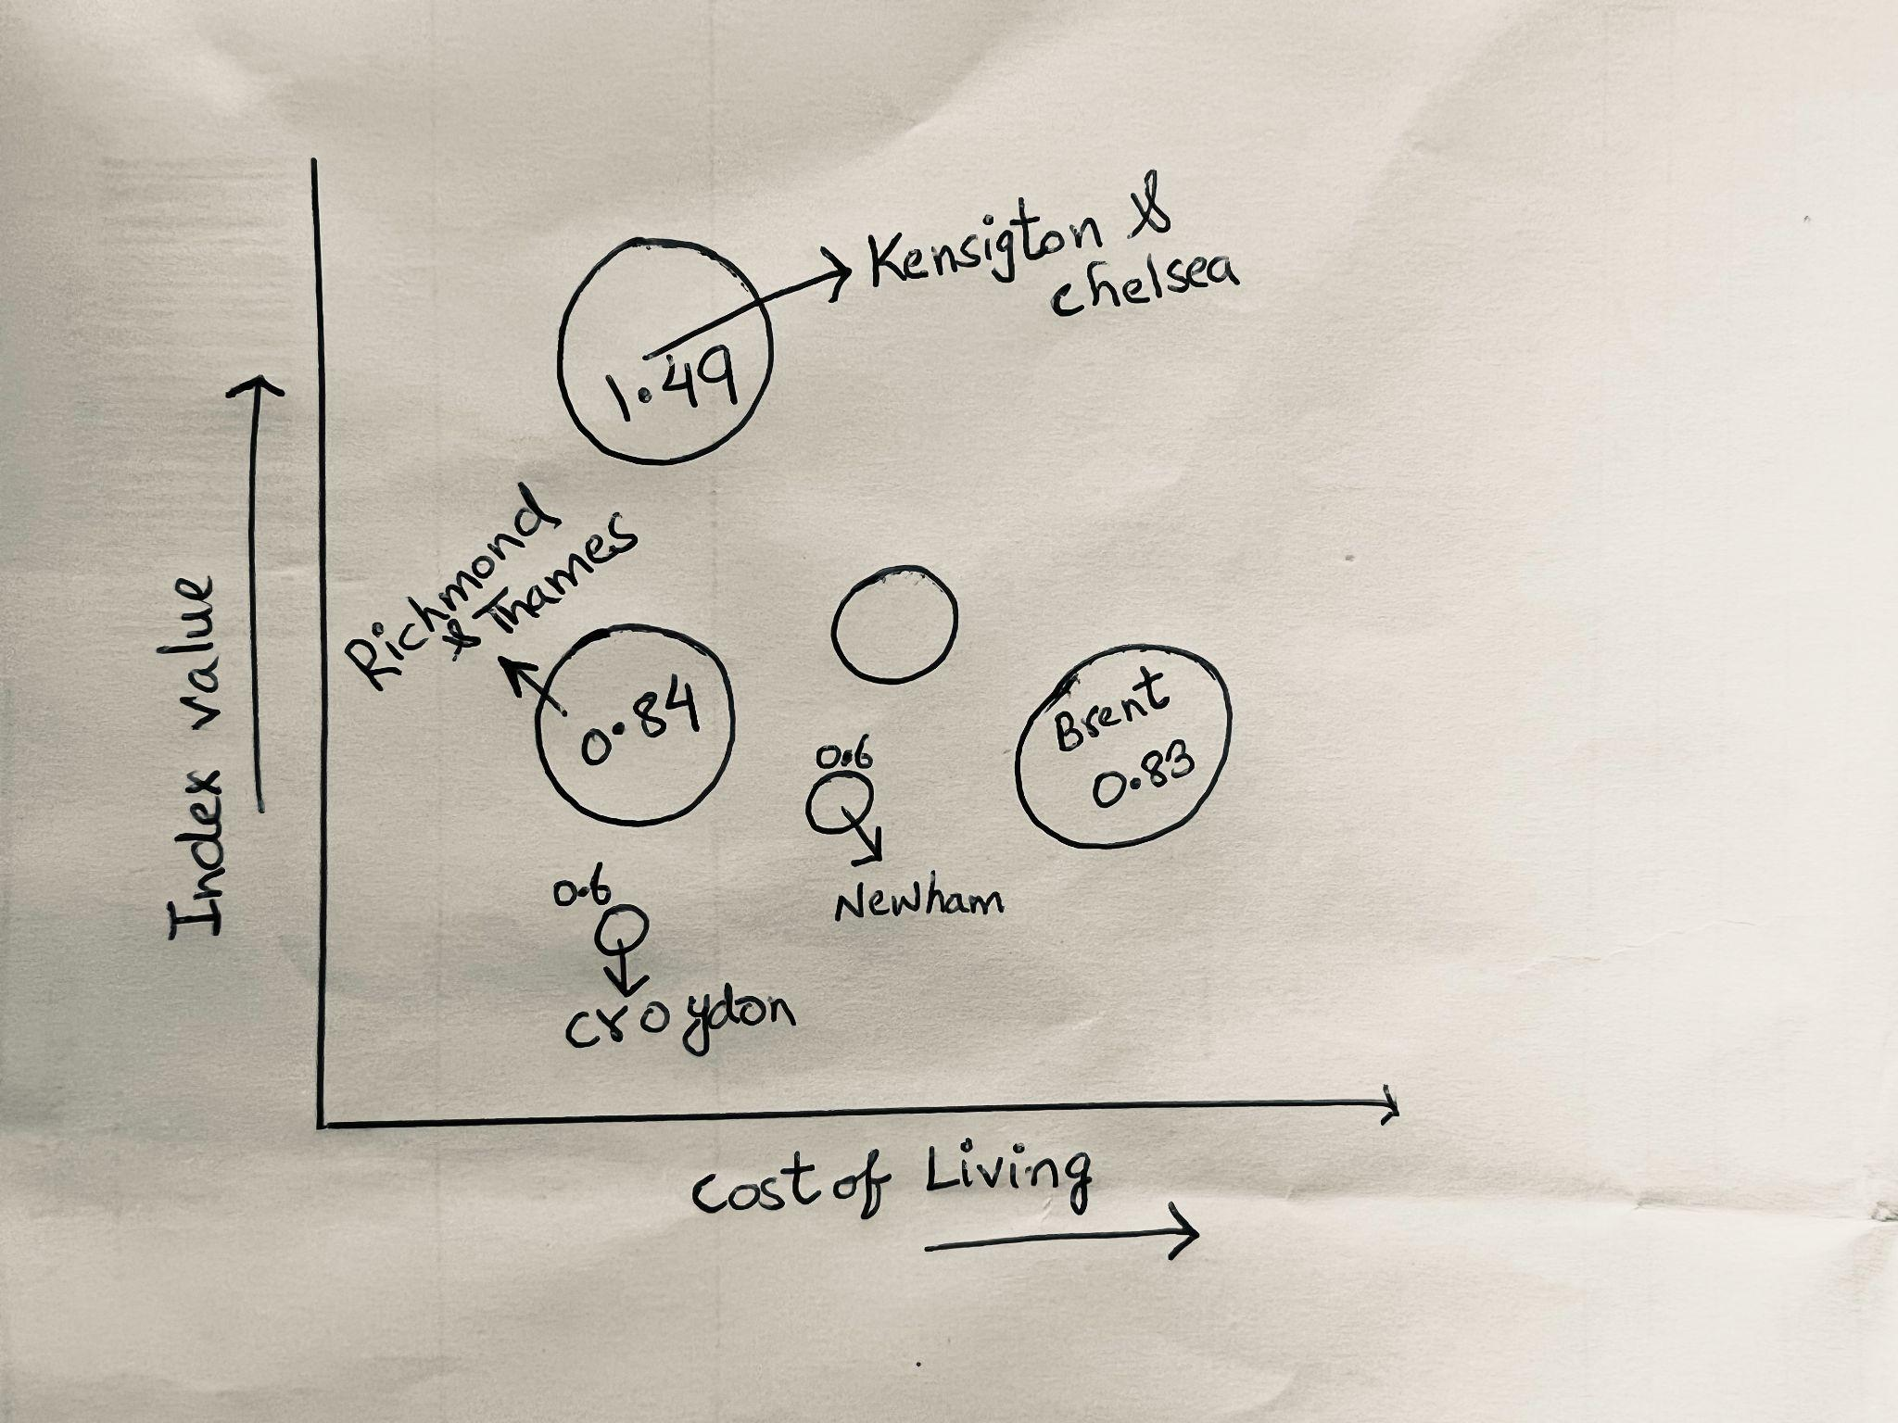

Sketch -2 [ Visualization 2: Stacked Bar Chart of Cost of Living Comparison between London and Other Major Cities ]

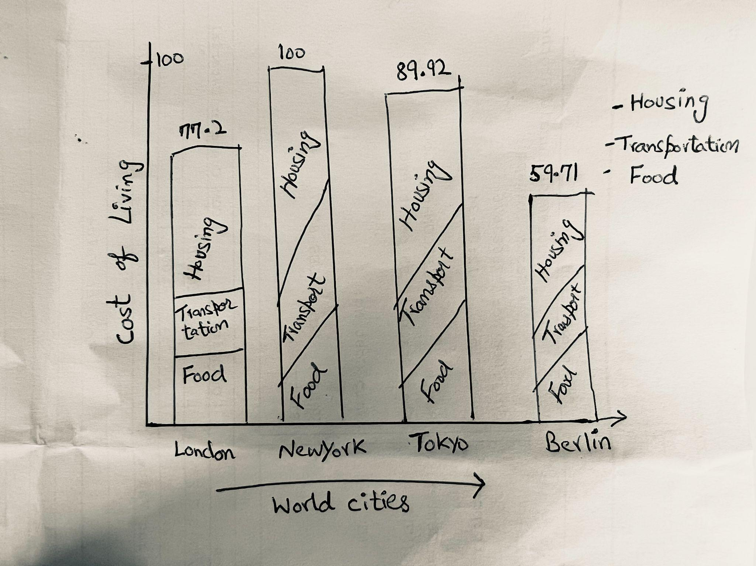

Sketch -3 [ Visualization 3: Line Chart of Cost of Living in London Over the Past Decade by Cost Category]

## 

## 2.2 Section B

**Visualization 1:** Bubble Chart of Factors Contributing to Cost of Living in London

**Design Rationale:**

A bubble chart would be an effective way to visualize the factors that contribute to the differences in the cost of living between different areas within London. Each borough would be represented by a bubble, with the size of the bubble indicating the cost of living index and the color representing the contributing factors such as housing, transportation, and food costs. This visualization would help to identify the key drivers of the cost of living in each borough and potentially highlight areas that require more attention from policymakers.

**An improvement over Existing Examples:**

While there are existing bubble charts that show the cost of living by the factor for different cities, this visualization could potentially improve upon existing examples by incorporating additional data such as demographic information and average income to provide more insights into the contributing factors of cost of living.

**Visualization 2:** Stacked Bar Chart of Cost of Living Comparison between London and Other Major Cities

**Design Rationale:**

A stacked bar chart would be an effective way to visualize the cost of living comparison between London and other major cities around the world. Each bar would represent a city, with the height of the bar indicating the cost of living index and the segments of the bar representing the different cost categories such as housing, transportation, and food. This visualization would help to identify the areas where London ranks higher or lower than other major cities and potentially highlight areas where London could improve its cost competitiveness.

**The Improvement over Existing Examples:**

While there are existing stacked bar charts that show the cost of living comparisons between different cities, this visualization could potentially improve upon existing examples by incorporating additional data such as average income and providing more detailed breakdowns of cost categories.

**Visualization 3:** Line Chart of Cost of Living in London Over the Past Decade by Cost Category

**Design Rationale:**

A line chart would be an effective way to visualize the changes in the cost of living in London over the past decade. Each line would represent a cost category, such as housing, transportation, and food, and the y-axis would represent the cost of living index. This visualization would help to identify the areas where the cost of living has increased or decreased the most over the past decade and potentially highlight areas where policymakers could focus their attention.

**An improvement over Existing Examples:**

While there are existing line charts that show the cost of living changes over time, this visualization could potentially improve upon existing examples by incorporating additional data such as average income and providing more detailed breakdowns of cost categories.

# Part 3. Implementation

shall be accompanied by a short description of how data are being processed (and acknowledgment of your data source(s)).

it can include either a composition of linked/related simple visual layouts or a more sophisticated single visual layout.

it shall allow some level of user interaction.

[See Attached Index.html]

# Further datasets and links

[1] data.london.gov.uk/dataset/financial-exclusion-and-poverty

[2] data.london.gov.uk/dataset/cost-of-living

[3] ons.gov.uk/economy/inflationandpriceindices/bulletis/consumerpriceinflation/march2021

[4] Kaggle (Cost of living.csv)

[5] GitHub ( world comparison Cost of Living Index.csv)

# Acknowledgements

The author acknowledges the generous support and help during difficult circumstances from the lecturers and teaching assistants at Kings College London, Department of Informatics.

# References

[1] Office for National Statistics. (2021). Consumer price inflation, UK: March 2021. [Online]. Available:<https://www.ons.gov.uk/economy/inflationandpriceindices/bulletins/consumerpriceinflation/march2021>. [Accessed: April 21, 2023].

For Changes in Rent/Mortgage Payments in London over Time:

[2] Office for National Statistics. (2021). Index of private housing rental prices, UK: March 2021. [Online]. Available:<https://www.ons.gov.uk/economy/inflationandpriceindices/bulletins/indexofprivatehousingrentalprices/march2021>. [Accessed: April 21, 2023].